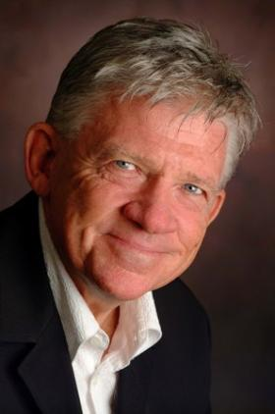
Barry Bull
$ 5,000 plus GST (Ex Sunshine Coast, QLD)
- His famous interviews with Sir Cliff Richard, Michael Crawford and Slim Dusty connect in special ways with audiences of all ages around Australasia.
- Barry Bull has fast become one of the country's top business speakers where his energetic presentations share the experience of his remarkable journey.
- Musician, record company executive, multi-award winning retailer, writer and record label owner, Barry is will inspire you with entertaining tales of his incredible journey through retail and beyond.
- Barry tells he built a small suburban music business into a national icon, by winning countless awards and attracting international superstars to his business, only to dismantle it and reinvent himself when times of change beckoned.
- Barry's energetic presentations are humorous, practical, told in an entertaining and memorable style with serious messages. It's an inspirational story of discovering your passion in life, and "taking the bull by the horns' and going for it.

Alan Casey Entertainment Agency - Australia
Brisbane - Sydney – Melbourne
Ph 1300 666 286 International 61 +7 3290 1733
office@alancaseyentertainment.com.au

