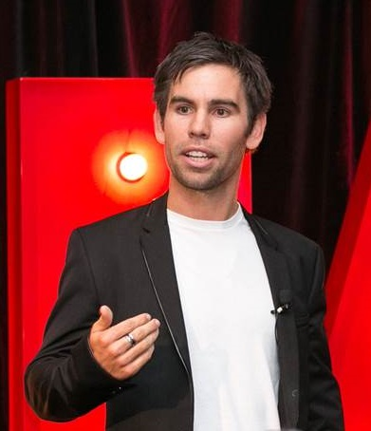
Brad Smith
$6,000 + GST (Ex Melbourne)
- In 2013, Brad won the Australian Retail Business of the Year Award at the Australian Business Champion Awards - for the fourth time! He also won the Telstra Victorian Business of the Year Award and braaap won a championship at the world title for their sport.
- Tasmanian born businessman Brad Smith is the designer of the braaap motorcycle and founder of the multi-million dollar Australian specialized small business of the year, braaap motorcycles.
- Brad is an entrepreneur with business interests in Manufacturing, Local Wholesaling, International Distribution, Franchising, Company owned Retail Stores, Online, Consumer Finance, Commercial Financing, Event Promotion, Property, stocks and Information products.
- 2010 TAS Young Australian of the Year and the 2008, 2009 Australian Young Entrepreneur of the year. He was 2013 World #4 for superlite motorcycle racing.
- At 17, he imported his first mini bikes from China and was disappointed with the quality, lost his money then worked hard to get himself to china at 18 years old to seek a manufacturing partner. After over 50 factories laughed him out of their office he created a deal with manufacturing partners from France, Italy, Canada, China, Japan and Australia. braaap built the only motorcycle on the planet with lifetime warranty, won a world championship and nine years later is in Australia, New Zealand, USA, France, UK, Russia and growing strong.
- With a vision to sell motorcycles alongside streetwear and lifestyle products Brad opened his first retail store. This business, braaap retail, has gone from strength to strength. He’s now franchising across Tasmania, Victoria and Australia, as well as opening stores in the USA.
- Their mission is to help young people get a clean adrenalin rush through activity, through action sports such as motorcycles or BMX rather than drugs, crime or violence. Brad and the braaap team have taught over 1000 kids to ride a motorcycle as part of their contribution to creating experiences that matter, to giving young people the tools to grow, and creating a memory for people who would not usually have the opportunity to ride.
- Brad is one of the most sought after speakers in Australia.

Alan Casey Entertainment Agency - Australia
Brisbane - Sydney – Melbourne
Ph 1300 666 286 International 61 +7 3290 1733
office@alancaseyentertainment.com.au

