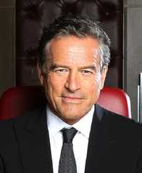
Mark Bouris
Ex Sydney
- Mark Bouris is best known as the founder of Wizard Home lones, Australias largest non-bank Mortgage leader
- Mark writes a number of financial columns for some of Australia's most recognised publications
- Author of Wealth Wizard and The Yellow Brick Road to Your Financial Security
- in 2005 he entered the BRW RIch 200 list and in 2007 entered the list of australians worth over a billion dollers for the second time
- Mark was host of of 2009 Australian version of The Apprentice on the nine network, and in 2011 hosted the smash hit Celebrity apprentice.

Alan Casey Entertainment Agency - Australia
Brisbane - Sydney – Melbourne
Ph 1300 666 286 International 61 +7 3290 1733
office@alancaseyentertainment.com.au

