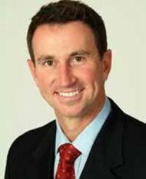
Duncan Armstrong
Topics:
- Achievements
- Goal Setting
- MC
- Olympian
- Sport
- Swimming
- Team Sport
Travels From: Brisbane, QLD

Raised in the Central Queensland town of Rockhampton, Duncan Armstrong rose to national and international fame at the Seoul Olympics in 1988 when he broke the world record to win the Gold medal in the 200 metres freestyle.
Duncan formed a winning relationship with madcap coach Laurie Lawrence which spanned 10 years, collecting Gold at the Commonwealth Games, Pan Pacific championships and numerous national and international competitions. During his stellar career Duncan also won a host of honours out of the water, including Young Australian of the Year and an Order of Australia medal.
After representing Australia at two Olympic Games, Duncan retired from the pool in 1993 to pursue a career in media and corporate coaching. Duncan is currently contracted with Fox Sports and presents all their swimming coverage, as well as hosts Fox Sports Central on Sundays. Athens 2004 was Duncan’s third Olympics as a commentator, where he brought all the action from poolside with Radio 2GB.
Duncan faces each year with his usual energetic youthfulness, and promises to deliver on every facet of his career. Media commitments will keep him well and truly in the limelight, while he continues to develop great corporate and community programs with his long-term business partners Westpac Banking Corporation and Telstra.

