Family Events - The Party Cave

Awesome family events are created when you hire THE PARTY CAVE, a two level trailer-mounted children's party pod for unforgettable kids disco/karaoke parties, delivered to your children's party.

NOW AVAILABLE IN Brisbane & PERTH AND SOON IN OTHER MAJOR CITIES
THE PARTY CAVE NOW INCLUDES TWO GIANT EXTERNAL WALL MOVIE/GAMING SCREENS
A one-stop party headquarters designed for children/teenagers/adults young at heart. The portable party pod is a transportable pod that is delivered to your event and collected on completion of the hire period.
The Party Cave is 5.6 metres long and 2.5 metres wide.

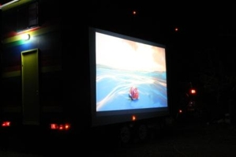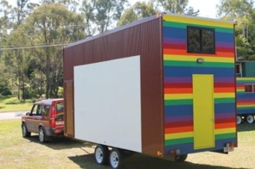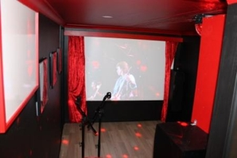
What is it?
The Party Cave is an all-new trailer-mounted party pod designed for delivery to your party address to transform your next party into party heaven. Designed for kids but teenagers and adults too will party on in the Party Cave!

Features Include
The Party Cave has both upstairs and downstairs areas both full of everything audio and visual to make your kids/ family party one that you and all partygoers will remember for long to come.
Some features include:-
- Upstairs Party Cave with x-box and playstation
- Dual racing wheels and chairs
- Viewing grid from upstairs to downstairs
- Dance floor with in-beat laser light and fog machine
- Home theatre screen and projector with playstation three
- Karaoke station and stage with dual microphones
- Singstar
- Limbo rock
- Retro jukebox
- DJstation with dual scratchie cd player
- Make -up station/wigs etc
- Refreshments bar including small bar fridge

Hire Charges for The Party Cave*
Daily hire period: Delivery : 2pm Collection: 10am following day (other deliveries/pick up times by arrangement)
​Payment terms: a deposit on booking. Balance of hire fee and transport 7days prior to delivery date.
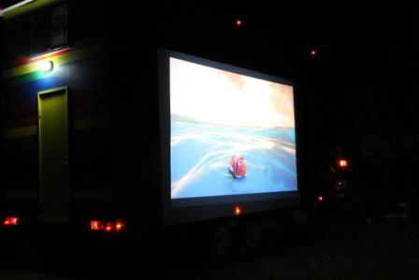 Movie screen on The Party Cave at night.

