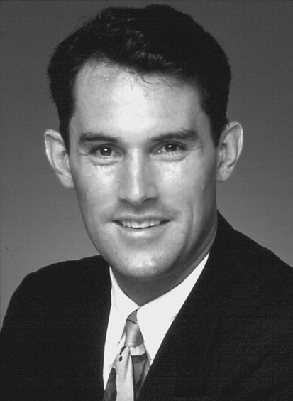

JOHN McGRATH

*SUCCESS * SELLING * MOTIVATION * ACHIEVEMENT*

John McGrath, a self-made millionaire at age 23, founded his own real estate company McGrath Partners Estate Agents at age 26.

Business Highlights:

- He commenced selling real estate in 1984 at 21 years, by the age of 24 years he had already set a number of real estate records including the sale of Australia’s most expensive house for $11.25 million.

- With no formal business training or educational qualifications John started McGrath Partners Estate Agents in 1989 from his own house.

- Today McGrath Partners is Australia’s largest real estate office turning in excess of $850 Million in sales annually, with over 115 staff, and growing.

- McGrath Partners is widely accredited with revolutionising the real estate industry through innovative drive and passion for client service.

- McGrath Partners runs the Real Estate School of Excellence established to provide leading edge training to new industry recruits.

- John is a winner of the Australasian Auctioneer Championships which judge the finest auctioneer in both Australia and New Zealand.

McGrath Partners have received numerous awards including both Sydney Real Estate Institute's "Best Overall Marketing Campaign Award" and "Best Corporate Image" twice, Winner of AFR/Telstra Award for Australia’s Best Commercial Web Site”, and Winner “Wentworth Business Awards for Most Outstanding Real Estate Company”.

John is also involved in community work. He has been involved with the Sydney City Mission and is on the Board of the Royal Hospital of Women Foundation.

Channel Nine's "60 Minutes" have featured John twice as one of Australia's three most successful young entrepreneurs and he is in high demand as a speaker. BRW have described John as “Perhaps Australia’s ultimate salesman”.

In outlining his success John's approach is fresh and simple - the traits required to excel in selling and business can be taught to anyone if they wish to learn.

SPEAKER

John speaks extensively on peak performance strategies and the maximising of success. He speaks with a blend of energy and dynamism, tailoring presentations after looking closely at your business, its culture, performance and ambitions.

Topics and areas covered to your brief:

- Positive Mental Attitude – the difference between winning and taking part.
- Turbo Boosting Sales – building a dynamic sales process for fast-track advancement.
- Taking the lead – the relationship between strong leadership and peak performance.
- The Internet & Technology – the Hottest Sales Tools this Century.
- Making the Transition from Good to Great.
- Creating a Personal Blueprint for Success.
- Focus on Teamwork and Team-building.

TYPICAL CLIENT FEEDBACK:

Advance Bank, St George Bank, Boral, Australian Heads of Government, AMP, American Express Travel, Holden Australia, Apple Computers, Telecom NZ, David Jones, Retravision……………………...

“John was excellent – he mixed the message the we asked with an extremely motivating message of how he achieved his success” American Express

“Totally and utterly inspiring – he significantly added to the value of our conference” hoo marketing

“Your delivery and content was absolutely brilliant and appealed to my entire team. I was truly amazed by their reaction and the receptiveness to your concepts.” Phillip Webb Pty Ltd

“You provided us with some much sought-after motivation and sound practical advice for both life and business in the new millennium. “ Seiko

“Presented sessions with lots of laughter and interest.” Aristocrat Technologies

