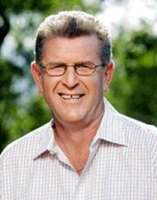
Pat Welsh
Topics:
- MC
- Media
- Sport
Travels From: Brisbane, QLD

Pat will need to obtain approval from Channel 7 before accepting any speaking engagement.
Pat Welsh is one of Australia’s leading sports journalists and commentators, with more than 20 years’ experience behind him.
Pat is best known for his rugby league and golfing commentaries, and has travelled extensively throughout Europe, Australia and the United Kingdom for the Seven Network. He has covered several Kangaroo tours and the 1992 Rugby League World Cup.
He is a familiar face at golfing tournaments, where he earned the nickname “Whispering” Pat Welsh for his hushed, on-course style and has covered the US Open and British Open golf tournaments for Seven Sport. He has been part of the Seven team at the Barcelona and Atlanta Olympic Games and introduced Australians to the delights of the Winter Olympic Games in Nagano.
Pat is a respected MC for Corporate events and functions.

