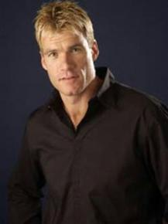
Richard Champion
Topics:
- Achievements
- AFL
- MC
- Media
- Motivational
- Sport
- Team Building
- Team Sport
Travels From: Brisbane, QLD

Richard Champion’s football career spanned fourteen years in total, including ten pivotal years with the Brisbane Bears/Lions before his retirement at the end of the 2000 season. During his career he finished in the top six places for the Best & Fairest Awards three times. He also won the Bears’ prestigious “Most Professional Player” award in 1994 and took “Best Clubman” honours in 1995.
At the conclusion of his career Champion won rarely-given, lavish praise from coach Leigh Matthews for the professional manner in which he conducted himself, having also qualified for entry to the AFL’s prestigious 200 Club. He was awarded Brisbane Lions Life Membership at the end of the 2000 season for his 10 years of loyal service to the club. Richard shares his experiences of life in football in a very entertaining way.
Richard also enjoyed showing off his vocal talents, or lack of them, on the hit series “It Takes Two”. His other media commitments include – television presenter with “The Great South East” and “Creek to Coast” with Channel Seven. He also co-hosts radio programmes and is a regular commentator on the AFL when the Brisbane Lions play at the Gabba. Richard's friendly yet professional manner makes him a very popular MC/host at corporate and sporting events and conferences.

