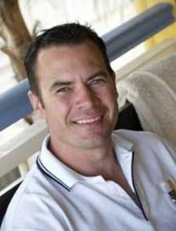
Rupert McCall
Topics:
- After Dinner
- Comedy
- Corporate Entertainment
- MC
- Media
- Sport
Travels From: Brisbane, QLD

Hailed as a modern-day Banjo Paterson, Rupert McCall has captured the imagination and stirred the souls of people all over Australia with his poetry. Rupert is unique to his field of entertainment. He embodies everything that is Australian and his lyrics associate with everyday people.
Rupert’s talents have been embraced at all levels over radio and television. Castlemaine Perkins utilised Rupert’s talents, knowing his passion and patriotism, by requesting him to write the Fourex advertisement entitled, “Home”. His versatility now sees him write for, and attend, corporate functions and conventions around Australia.
Rupert’s collection of poetry has accumulated significantly which has resulted in the publication of four anthologies of verse that have collectively sold over 100,000 copies. He continues to captivate and enthral audiences in his corporate presentations.

