Terry Morris
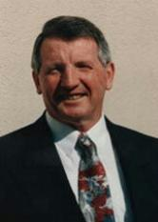
Topics:
- Achievements
- Branding
- Business Success
- CEO/MD
- Food/Wine
- Management
- Marketing
- Resilience
- Success
- Strategy and Planning

Travels from: Gold Coast, QLD

Terry Morris is Managing Director of the Gold Coast-based Group of Companies incorporating Information Technology, Data Processing and Property Investment.

Mr Morris’s diverse interests include the Arts, (he is Chairman of the Gold Coast Arts Centre Foundation’s Fundraising Committee) and motorsports (Honorary Chairman of Formula Ford Association).

Back in 1981 in conjunction with his son Paul, he created the direct marketing business Today, the Group employs over 360 people.

Today, Terry is actively involved in his businesses including Sirromet Wines Pty Ltd (Queensland’s Premier Winery), Pronto Direct Pty Ltd (Direct Mail Lettershop), Morris International (Data Processing, Order Fulfilment), The Holden Performance Driving Centre, Carrara Markets and TEMA Property Services (Property Management and Investment). All his businesses have had to adapt and re-invent themselves to maintain business with an ever-changing market.

